NAME:M .NAVEEN KUMAR

SECTION:K18GE

ROLL NO:65

STUDENT ID:11806317

PROJECT SUB NAME: OPERATING SYSTEM

EMAIL:mnk4698@gmail.com

// Banker's Algorithm

#include <stdio.h>

int main()

{

// P0, P1, P2, P3, P4 are the Process names here

int n, m, i, j, k;

n = 5; // Number of processes

m = 3; // Number of resources

int alloc[5][3] = { { 0, 1, 0 }, // P0 // Allocation Matrix

{ 2, 0, 0 }, // P1

{ 3, 0, 2 }, // P2

{ 2, 1, 1 }, // P3

{ 0, 0, 2 } }; // P4

int max[5][3] = { { 7, 5, 3 }, // P0 // MAX Matrix

{ 3, 2, 2 }, // P1

{ 9, 0, 2 }, // P2

{ 2, 2, 2 }, // P3

{ 4, 3, 3 } }; // P4

int avail[3] = { 3, 3, 2 }; // Available Resources

int f[n], ans[n], ind = 0;

for (k = 0; k < n; k++) {

f[k] = 0;

}

int need[n][m];

for (i = 0; i < n; i++) {

for (j = 0; j < m; j++)

need[i][j] = max[i][j] - alloc[i][j];

}

int y = 0;

for (k = 0; k < 5; k++) {

for (i = 0; i < n; i++) {

if (f[i] == 0) {

int flag = 0;

for (j = 0; j < m; j++) {

if (need[i][j] > avail[j]){

flag = 1;

break;

}

}

if (flag == 0) {

ans[ind++] = i;

for (y = 0; y < m; y++)

avail[y] += alloc[i][y];

f[i] = 1;

}

}

}

}

printf("Following is the SAFE Sequence\n");

for (i = 0; i < n - 1; i++)

printf(" P%d ->", ans[i]);

printf(" P%d", ans[n - 1]);

return (0);

// This code is contributed by Deep Baldha (CandyZack)

}

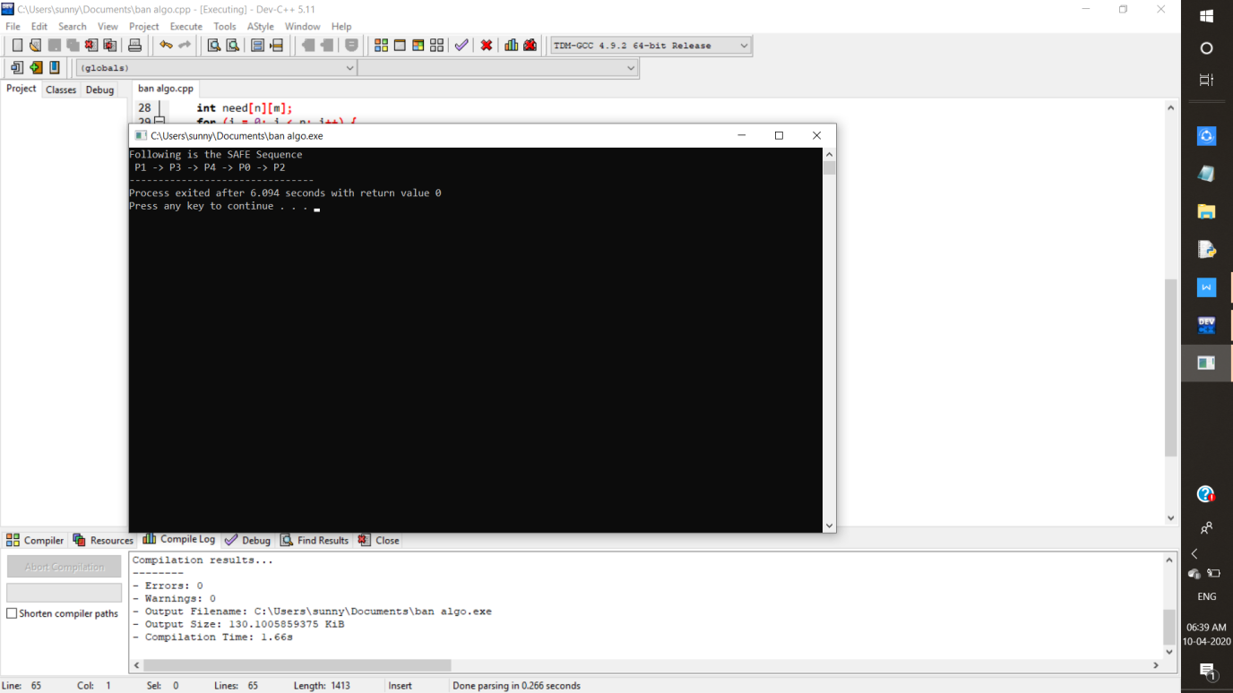

BANKERS ALGO:

Banker’s algorithm is named so because it is used in banking system to check whether loan can be sanctioned to a person or not. Suppose there are n number of account holders in a bank and the total sum of their money is S. If a person applies for a loan then the bank first subtracts the loan amount from the total money that bank has and if the remaining amount is greater than S then only the loan is sanctioned. It is done because if all the account holders comes to withdraw their money then the bank can easily do it.

In other words, the bank would never allocate its money in such a way that it can no longer satisfy the needs of all its customers. The bank would try to be in safe state always.

Following **Data structures** are used to implement the Banker’s Algorithm:

Let **‘n’**be the number of processes in the system and **‘m’**be the number of resources types.

**Available :**

* It is a 1-d array of size **‘m’** indicating the number of available resources of each type.
* Available[ j ] = k means there are **‘k’** instances of resource type **Rj**

**Max :**

* It is a 2-d array of size ‘**n*m’**that defines the maximum demand of each process in a system.
* Max[ i, j ] = k means process **Pi** may request at most **‘k’** instances of resource type **Rj.**

**Allocation :**

* It is a 2-d array of size**‘n*m’**that defines the number of resources of each type currently allocated to each process.
* Allocation[ i, j ] = k means process **Pi** is currently allocated **‘k’** instances of resource type **Rj**

**Need :**

* It is a 2-d array of size **‘n*m’** that indicates the remaining resource need of each process.
* Need [ i,   j ] = k means process **Pi** currently need **‘k’** instances of resource type **Rj**

for its execution.

* Need [ i,   j ] = Max [ i,   j ] – Allocation [ i,   j ]

Allocationi specifies the resources currently allocated to process Pi and Needi specifies the additional resources that process Pi may still request to complete its task.

Banker’s algorithm consists of Safety algorithm and Resource request algorithm

**Safety Algorithm**

The algorithm for finding out whether or not a system is in a safe state can be described as follows:

*1) Let Work and Finish be vectors of length ‘m’ and ‘n’ respectively.  
Initialize: Work = Available  
Finish[i] = false; for i=1, 2, 3, 4….n*

*2) Find an i such that both  
a) Finish[i] = false  
b) Needi <= Work  
if no such i exists goto step (4)*

*3) Work = Work + Allocation[i]  
Finish[i] = true  
goto step (2)*

*4) if Finish [i] = true for all i  
then the system is in a safe state*

**Resource-Request Algorithm**

Let Requesti be the request array for process Pi. Requesti[j] = k means process Pi wants k instances of resource type Rj. When a request for resources is made by process Pi, the following actions are taken:

*1) If Requesti <= Needi  
Goto step (2) ; otherwise, raise an error condition, since the process has exceeded its maximum claim.*

*2) If Requesti <= Available  
Goto step (3); otherwise, Pi must wait, since the resources are not available.*

*3) Have the system pretend to have allocated the requested resources to process Pi by modifying the state as  
follows:  
Available = Available – Requesti  
Allocationi = Allocationi + Requesti  
Needi = Needi– Requesti*